BUSINESS INTELLIGENCE REPORT

By Josiah Oborekanhwo

**TABLE OF CONTENTS**

CUSTOMER RETENTION 3

What is Customer Churn? 3

Objectives 3

Machine Learning 11

Logistic Regression 11

Gradient Boost Classifier 11

Random Forest 12

K-Nearest Neighbors (KNN) 13

In Conclusion 13

CUSTOMER SEGMENTATION: CLASSIFICATION 13

Dimensionality reduction 15

Clustering 16

Evaluating Models 16

Classifying customers based on Quantity and Total Cost Price. 17

Classifying customers based on total amount of orders 18

Classifying customers based on redeemed loyalty points 19

Profiling 19

Group 0 19

Group 1 19

Group 2 19

Group 3 20

Conclusion 20

PRODUCT RECOMMENDATION 20

REVENUE OPTIMIZATION 21

Areas of Revenue to Optimize 21

Acquisition 21

Retention 21

Expansion 22

Pricing 22

# CUSTOMER RETENTION

## What is Customer Churn?

Customer churn is defined as when customers or subscribers discontinue doing business with a firm or service.

Customers in the food and commodity industry can choose from a variety of service providers and actively switch from one to the next.

Individualized customer retention is tough because most firms have a large number of customers and can't afford to devote much time to each of them. The costs would be too great, outweighing the additional revenue. However, if a corporation could forecast which customers are likely to leave ahead of time, it could focus customer retention efforts only on these "high risk" clients. The ultimate goal is to expand its coverage area and retrieve more customer loyalty. The core to succeed in this market lies in the customer itself.

Customer churn is a critical metric because it is much less expensive to retain existing customers than it is to acquire new customers.

To detect early signs of potential churn, one must first develop a holistic view of the customers and their interactions across numerous channels, including store/branch visits, product purchase histories, customer service calls, Web-based transactions, and social media interactions, to mention a few.

As a result, by addressing churn, businesses may not only preserve their market position, but also grow and thrive. More customers they have in their network, the lower the cost of initiation and the larger the profit. As a result, the company's key focus for success is reducing client attrition and implementing effective retention strategy.

## Objectives

I will explore the data and try to answer some questions like:

* What's the % of Churn Customers and customers that keep in with the active services?
* Is there any patterns/preference in Churn Customers based on the type of service provided?
* What's the most profitable service types?
* Which features and services are most profitable?
* Which machine learning model is best for prediction?

All of my workings and analysis were carried out on Jupyter Notebook which can be found [here](https://github.com/Josiah-Jovido/TopUpReport/blob/main/Customer_Retention_%26_Churn.ipynb).

**KENYA**

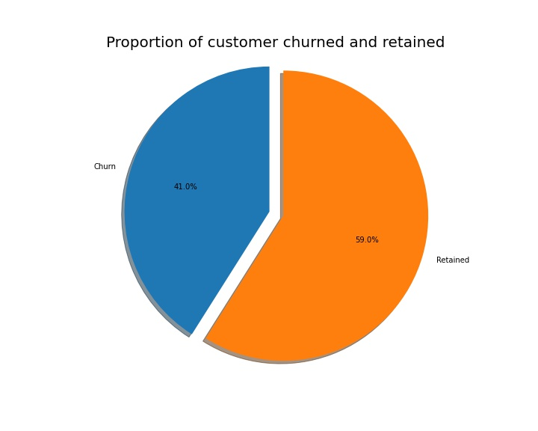

Figure 1: Proportion of customer churned and retained

From the figure above, 41% of Kenyan customers have a high probability of moving out.

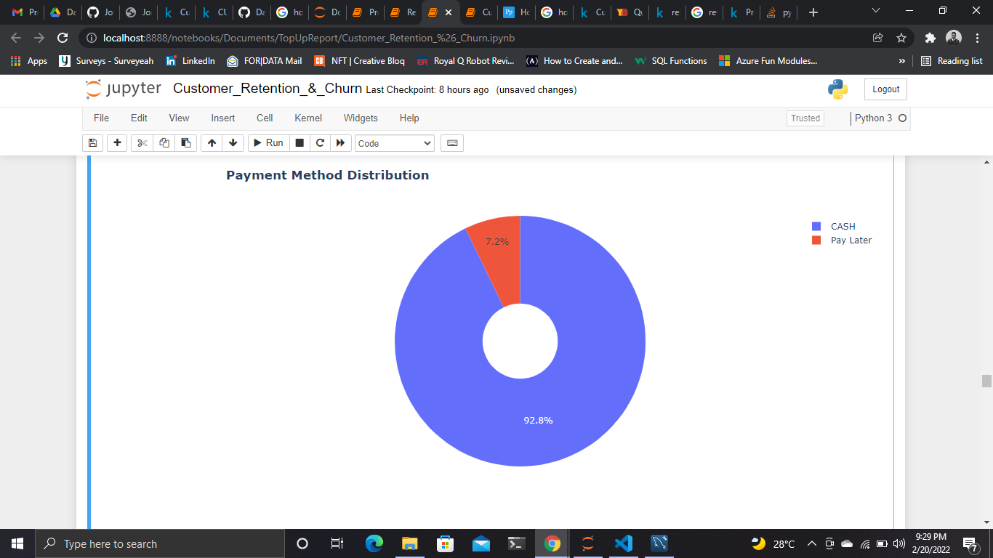

Figure 2: Payment method distribution

92.8% of Kenyan customers opted in for cash payment method than pay later. This might be due to the convenience of paying with cash such as; payment on delivery, safer transaction as product is seen before payment etc.

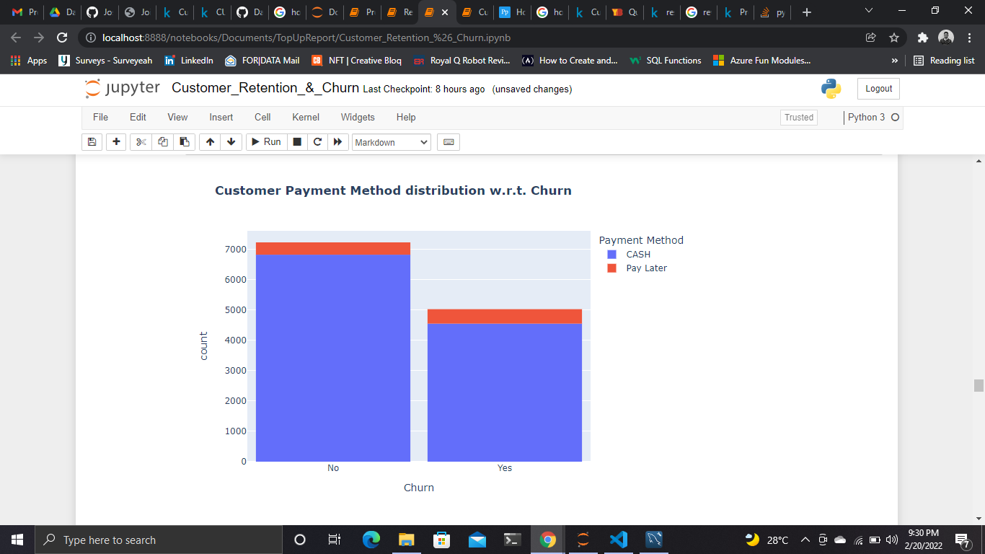

Figure 3: Customer payment method distribution w.r.t churn

A large amount of Kenyan customers engage more with cash payment method, as a result, this factor has little influence on the churn rate. Another takeaway that can be put into consideration is the constraint that cash payment brings, for example, a customer without access to cash might prefer POS or bank transfer payment method but due to the constraint in payment options the customer might choose to opt out of the service.

More added insights;

* Major customers who moved out where having cash as payment methods
* Customers who opted for cash payment were also less likely to move out

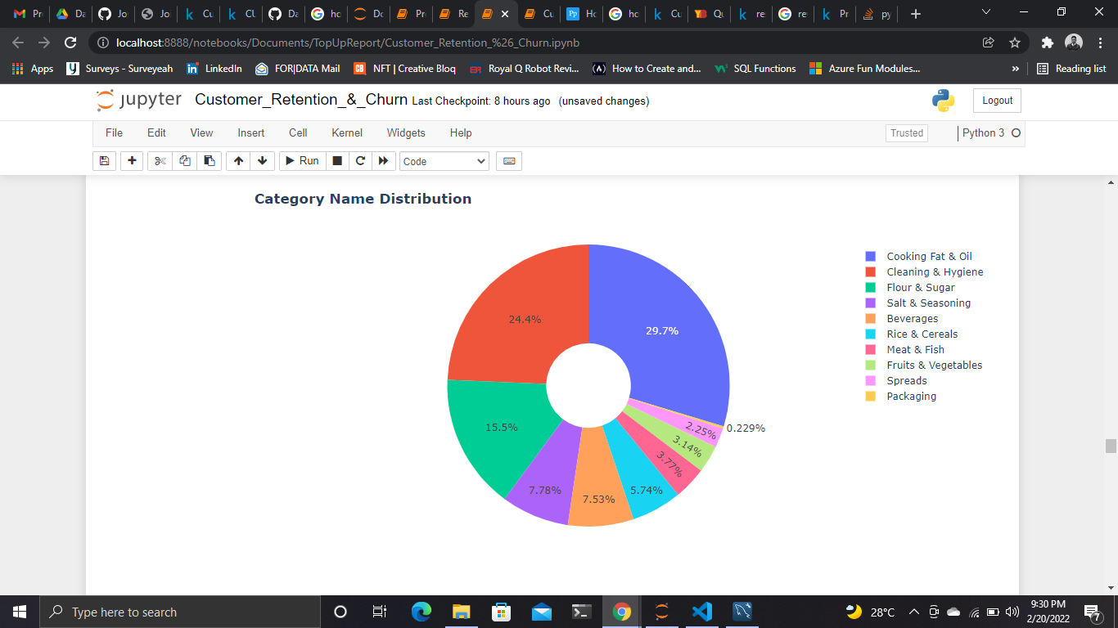

Figure 4: Category Name distribution

Cooking fat & oil, cleaning & hygiene, flour & sugar, are the major products being purchased by customers in Kenya. They cover 29.7%, 24.4% and 15.5% of the total product purchase type respectively.

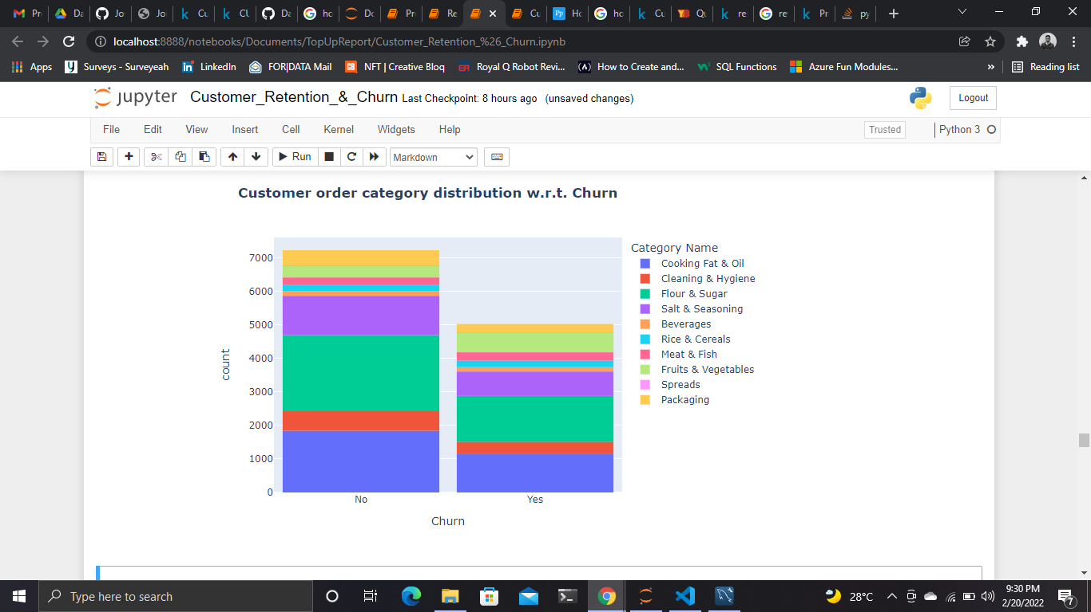

Figure 5: Customer order category distribution w.r.t churn

Customers who orders cooking fat & oil, flour & sugar have a higher churn rate. This might suggest a dissatisfaction with the type of service provided.

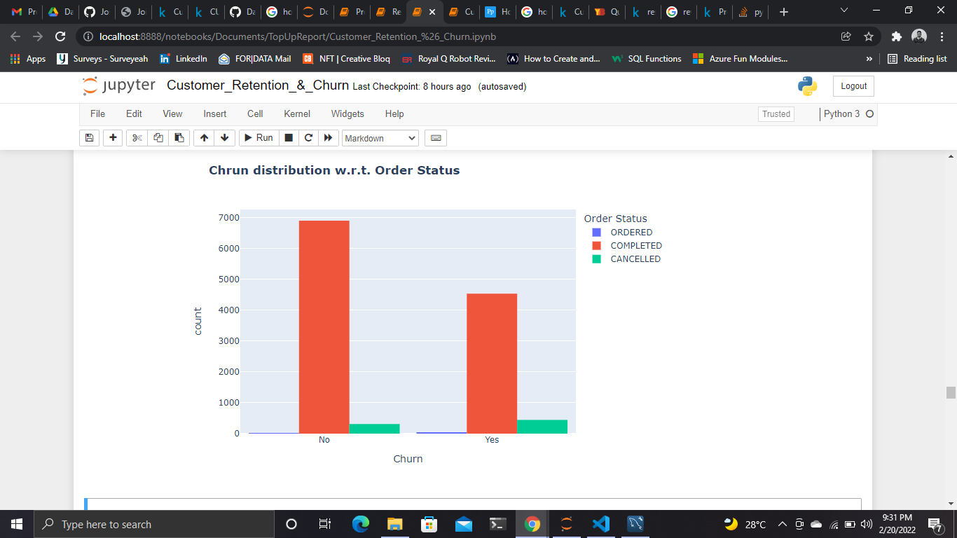

Figure 6: Churn distribution w.r.t order status

* Customers with more completed orders are likely to stay
* Customers with high amount of cancelled orders are more likely to churn

**NIGERIA**

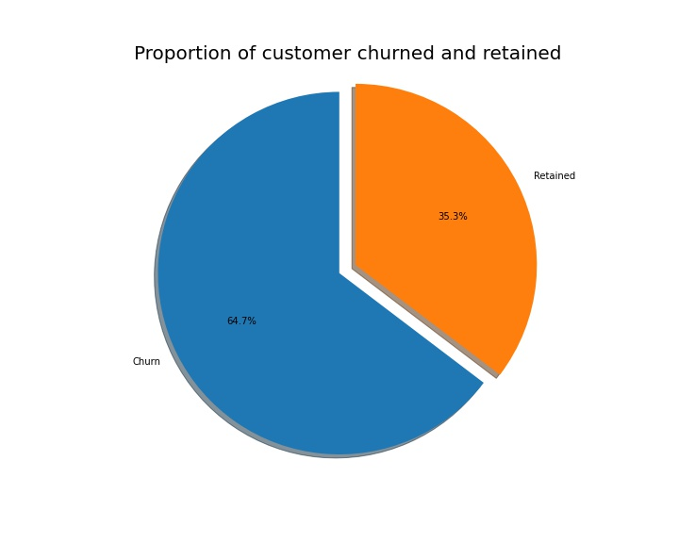

Figure 7: Proportion of customer's churned and retained in Nigeria

There is a high amount of churn rate among Nigerian customers. 64.7% of customers have a high probability of moving out of the service

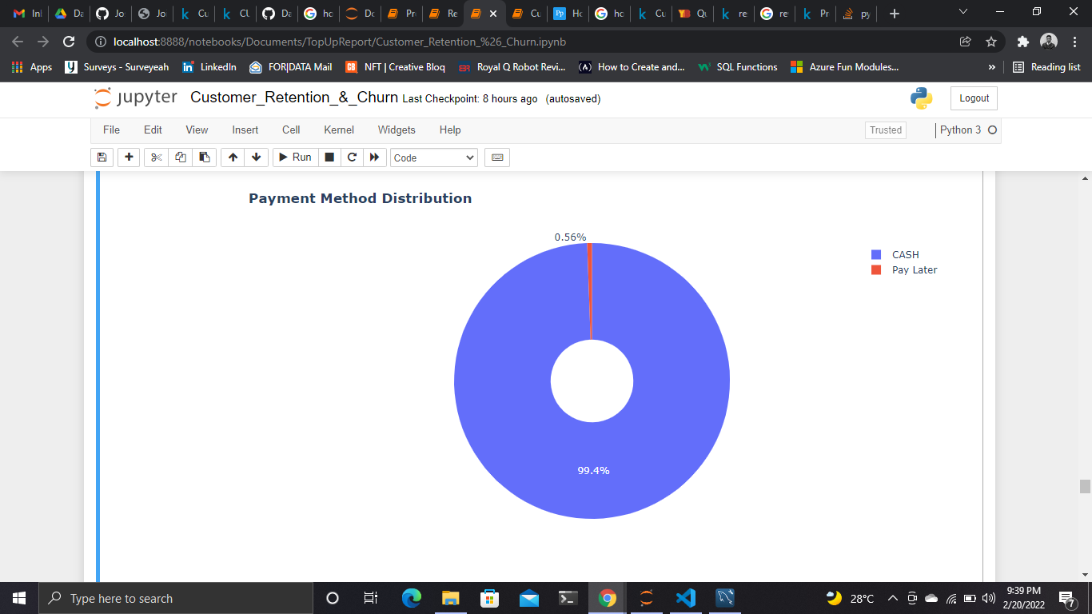

Figure 8: payment method distribution in Nigeria

99.4% of Nigerian customers opted in for cash payment method rather than pay later. This might be due to the convenience of paying with cash such as; payment on delivery, safer transaction as product is seen before payment etc.

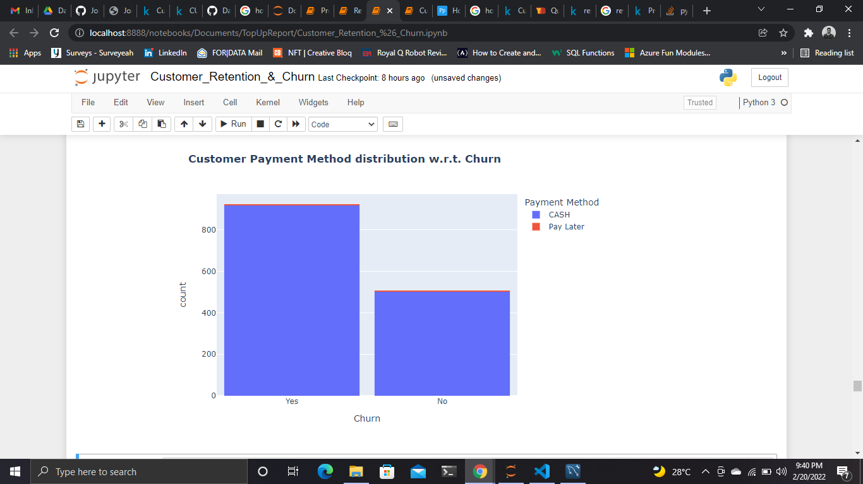

Figure 9: Nigeria’s customer payment method w.r.t churn

This factor does not have a strong effect on the churn rate as most of Nigeria‘s customers already engage with cash payment method. Another takeaway that can be put into consideration is the constraint that cash payment brings, for example, a customer without access to cash might prefer POS or bank transfer payment method but due to the constraint in payment options the customer might choose to opt out of the service.

More added insights:

* Major customers who moved out where having cash as payment method.
* Customers who opted for cash payment method were also less likely to move out.

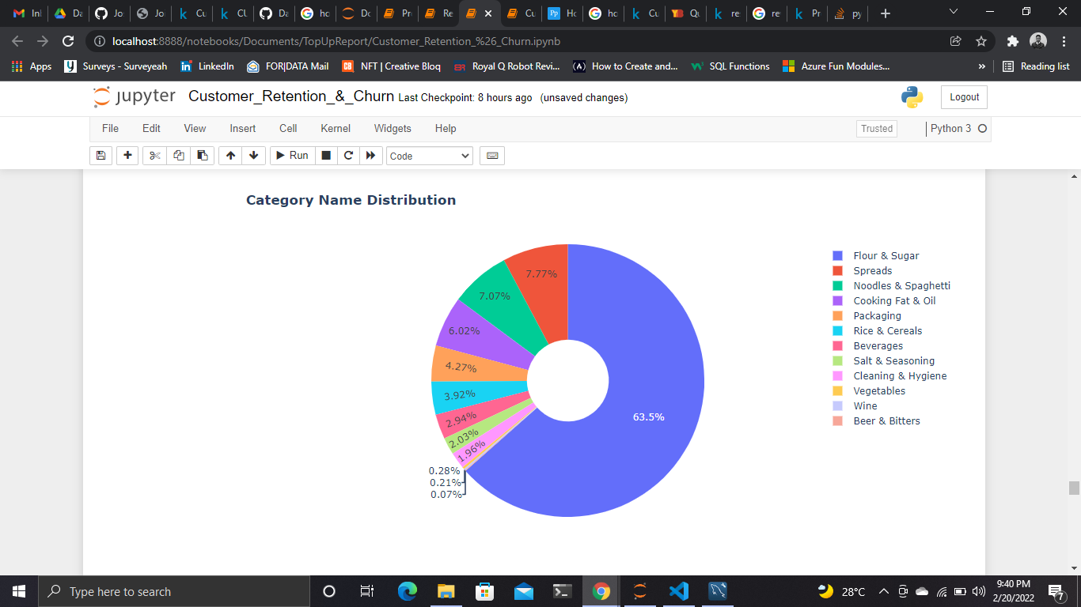

Figure 10: Nigeria’s category name distribution

Flour & sugar is the major product purchased by Nigerians followed by spreads, noodles & spaghetti, cooking fat & oil. Beer & bitters is the product with the least purchase history. More attention should be paid to this category to yield more sales.

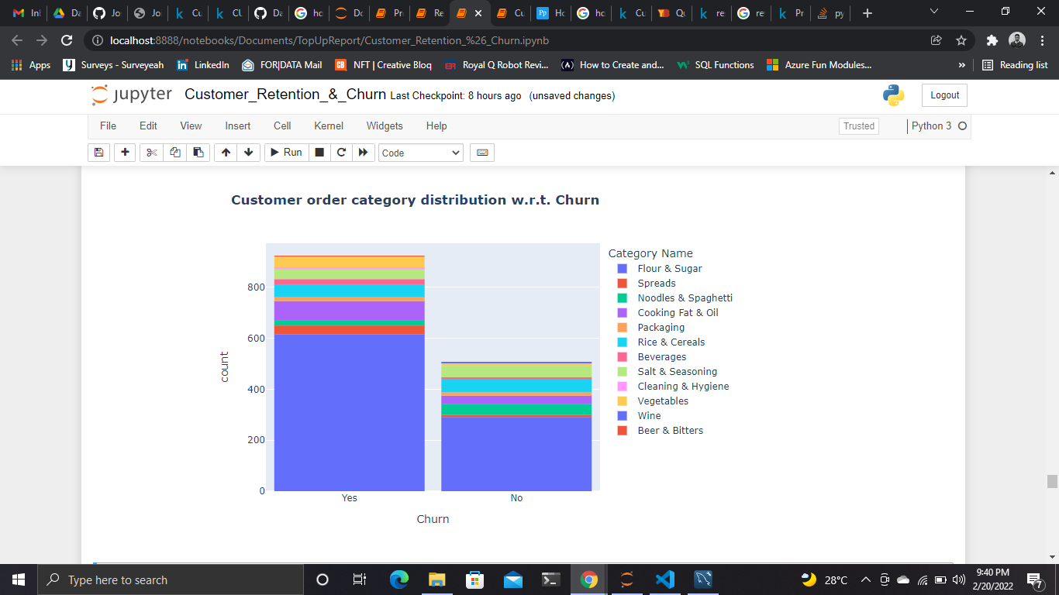

Figure 11: Nigeria’s customer order category W.R.T churn

Customers who order flour and sugar have a high churn rate. This might suggest a dissatisfaction with the type of service provided

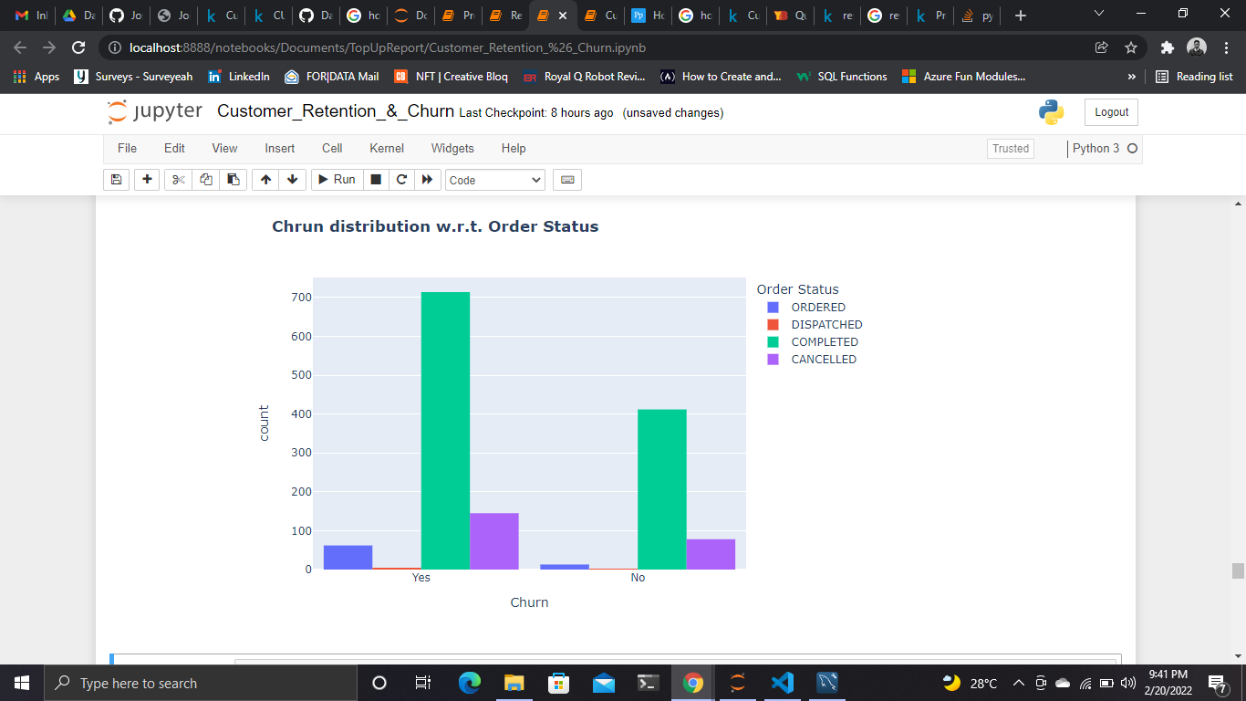

Figure 12: Nigeria's distribution w.r.t order status

* Customers with more completed orders are likely to stay
* Customers with high amount of cancelled orders are more likely to churn

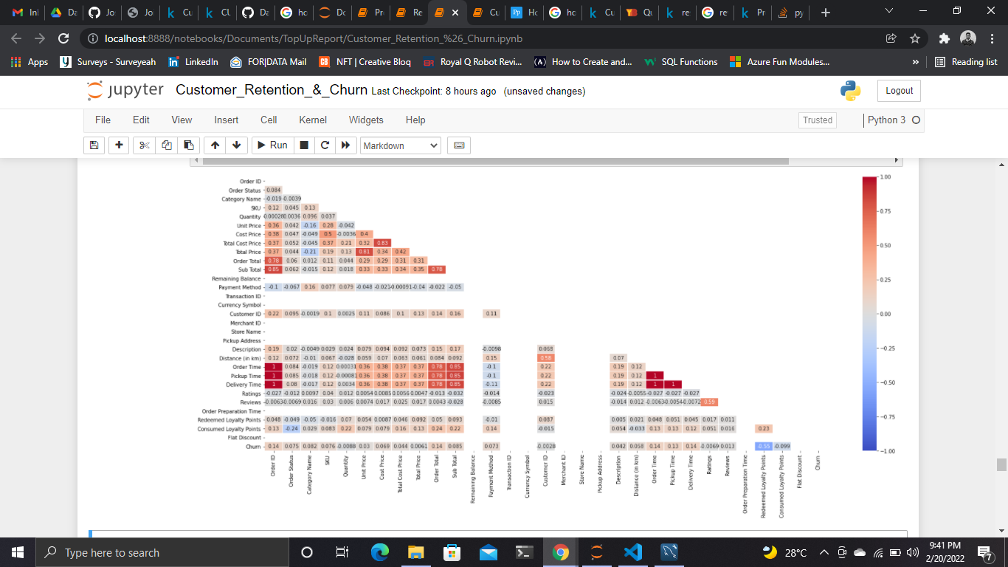

Figure 13: Correlation matrix

The correlation graph shows the relationship between the features and target variable. It guided the data preprocessing stage which helps to prepare the data for machine learning.

## MACHINE LEARNING

I tried out four (4) machine learning models (KNN, Logistic Regression, Gradient Boost Classifier and Random Forest) in training before picking the best for evaluation.

### Logistic Regression

The model had an accuracy of 0.6182707993474714, this is a fairly good score but I knew more could be achieved. From the ROC curve, we can see that the model has a fairly good true positive rate (correctly made predictions) in comparison to the false positive rate.

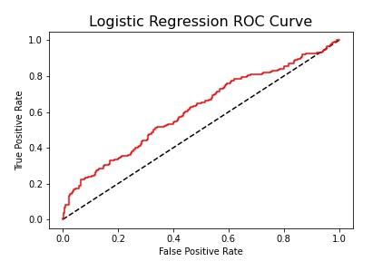

Figure 14: Logistic regression ROC curve

### Gradient Boost Classifier

The model had an accuracy score of 1.0. This is a bad sign and it means that the model is over-fitted, using a model like this will give you false predictions. From the Gradient boost confusion matrix, we can see that there is a total of 378 actual non churn values and the model predicted 378 non churn values, this is caused by the model over generalization due to over-fitting, therefore the model is not best to use for this scenario.

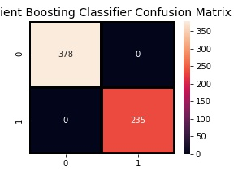

Figure 15: Gradient boosting classifier confusion matrix

### Random Forest

The model had an accuracy of 1.0 (An overly perfect score), another case of over-fitting, here I used the ROC curve to buttress my point. The ROC curve shows the trade-off between sensitivity (and TPR) and specificity (1 – FPR). Classifiers that give curve closer to the top-left corner indicate a better performance. As a baseline, a random classifier is expected to give points lying along the diagonal (FPR = TPR). The closer the curve comes to the 45 degree diagonal of the ROC space, the less accurate the predictions. And we can see below that the curve falls perfectly on the 45 degree diagonal, meaning, we can’t trust the predictions of this model.

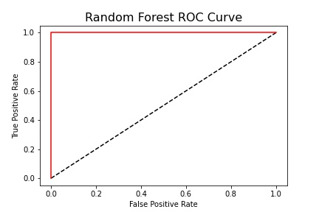

Figure 16: Random forest ROC curve

### K-Nearest Neighbors (KNN)

KNN was the best model for prediction in this case. The model had an accuracy score of 0.799347471451876 and from the KNN confusion matrix we can see that there are a total of (316 + 62 = 378) actual non-churn values and the algorithm predicts 316 of them as non-churn and 62 of them as churn. While there are (61 + 174 = 235) actual churn values and the algorithm predicts 61 of them as non-churn values and 174 of them as churn values.

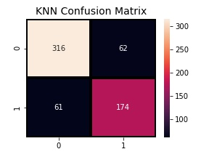

Figure 17: KNN confusion matrix

## In Conclusion

Customer churn is definitely bad to a firm’s profitability. Various strategies can be implemented to eliminate customer churn. The best way to avoid customer churn is for a company to truly know its customers. This includes identifying customers who are at risk of churning and working to improve their satisfaction. Improving customer service is, of course, at the top of the priority for tackling this issue. Building customer loyalty through relevant experiences and specialized service is another strategy to reduce customer churn. Another method involves surveying customers who have already churned to understand their reasons for leaving in order to adopt a proactive approach to avoiding future customer churn.

# CUSTOMER SEGMENTATION: CLASSIFICATION

I performed unsupervised clustering of data on the customer's records that were given. Customer segmentation is the practice of separating customers into groups that reflect similarities among customers in each cluster. I will divide customers into segments to optimize the significance of each customer to the business. To modify products according to distinct needs and behaviors of the customers. It also helps the business to cater to the concerns of different types of customers.

**Kenya**

There are 10 types of products that Kenyan customers’ orders and the latest order date in the records is 2022-02-17 while the oldest order date in the records is 2022-01-01.

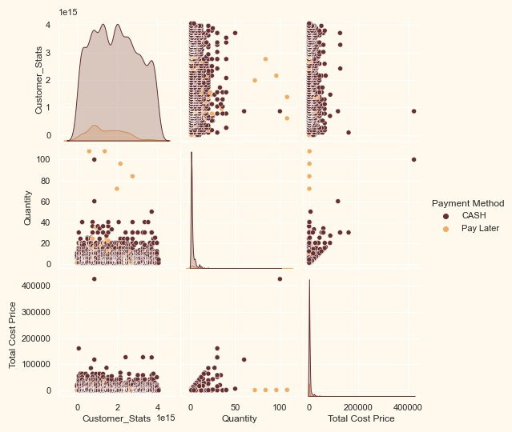

Figure 18: Pair plot

From the pair plot above it can be clearly seen that Kenyan customers are the type that prefers paying in cash than pay later.

## Dimensionality reduction

In this problem, there are many factors on the basis of which the final classification will be done. These factors are basically attributes or features. The higher the number of features, the harder it is to work with it. Many of these features are correlated, and hence redundant. This was why I performed dimensionality reduction on the selected features before putting them through a classifier. Dimensionality reduction is the process of reducing the number of random variables under consideration, by obtaining a set of principal variables.

**Principal component analysis (PCA)** is a technique for reducing the dimensionality of such datasets, increasing interpretability but at the same time minimizing information loss.

**Steps in this section:**

* Dimensionality reduction with PCA
* Plotting the reduced data frame
* Dimensionality reduction with PCA

For this project, I reduced the dimensions to 3.

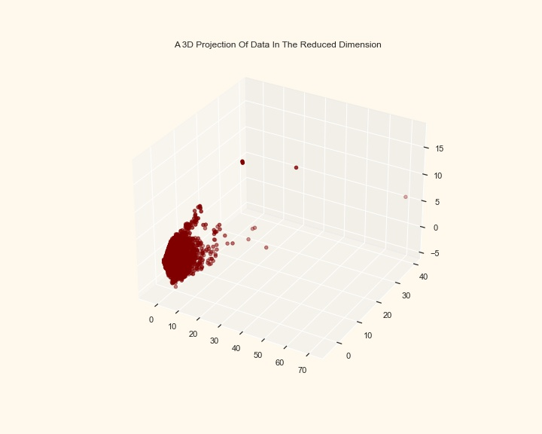

Figure 19: A 3D Projection of data in the reduced dimension

## Clustering

After reducing the attributes to three dimensions, I performed clustering via **Agglomerative clustering**. Agglomerative clustering is a hierarchical clustering method. It involves merging examples until the desired number of clusters is achieved.

Steps involved in the Clustering

* Elbow Method to determine the number of clusters to be formed
* Clustering via Agglomerative Clustering
* Examining the clusters formed via scatter plot.

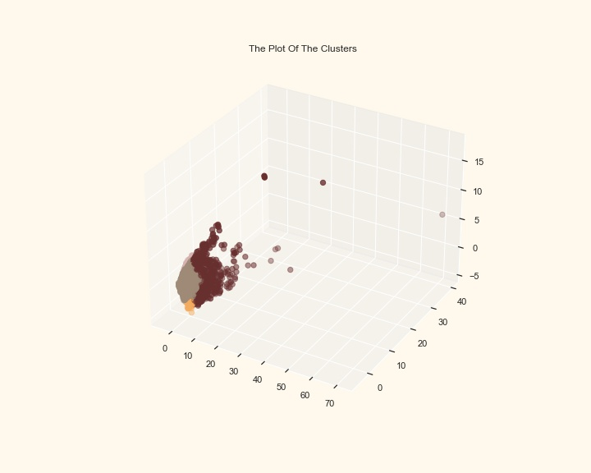

Figure 20: The plot of the clusters

## Evaluating Models

Since this was an unsupervised clustering. We do not have a tagged feature to evaluate or score our model. The purpose of this section is to study the patterns in the clusters formed and determine the nature of the clusters' patterns.

For that, I had a look at the data in light of clusters via exploratory data analysis and drawing conclusions.

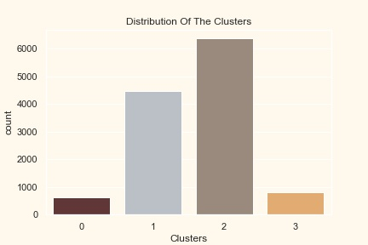

Figure 21: Distribution of the clusters

The clusters seem to be normally distributed.

### Classifying customers based on Quantity and Total Cost Price.

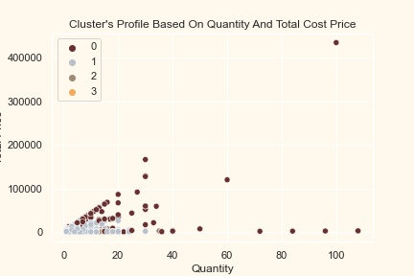

Figure 22: Cluster's profile based on quantity and total cost price

Total Cost Price vs. Quantity plot shows the clusters pattern

* **group 0**: high price buyers & high quantity
* **group 1**: low price buyers & average quantity
* **group 2**: low price buyers & average quantity
* **group 3**: low price buyers & low quantity

### Classifying customers based on total amount of orders

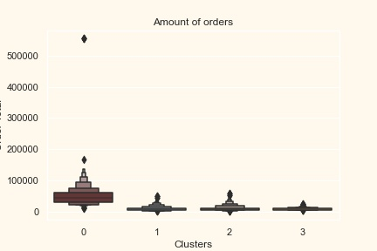

Figure 23: Customer classification based on total amount of orders

From the above plot, it can be clearly seen that cluster 0 is our biggest set of customers followed by cluster 2.

### Classifying customers based on redeemed loyalty points

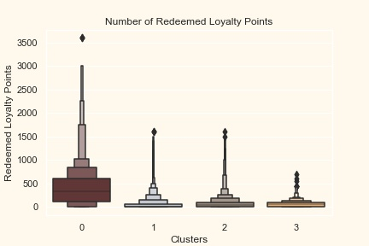

Figure 24: Number of redeemed loyalty points

The loyalty points seem to be working well in getting customers to engage. It has best outcome with cluster 0, cluster 1 and cluster 2. However, nothing seems to attract cluster 3 overwhelmingly.

## Profiling

After forming the clusters and looking at their purchasing habits. I profiled the clusters formed and came to a conclusion about who is our star customer and who needs more attention from the marketing team.

### Group 0

* High income group
* Bulk quantity buyers
* High price buyers

### Group 1

* Average income group
* Average quantity buyers
* Average price buyers

### Group 2

* Low income group
* Average quantity buyers
* Low price buyers

### Group 3

* Low income group
* Low quantity buyers
* Low price buyers

Group 0 is the company’s star buyers while more attention should be paid to group 3 by the marketing team.

## Conclusion

I performed unsupervised clustering. I used dimensionality reduction followed by agglomerative clustering. I came up with 4 clusters and further used them in profiling customers in clusters according to their purchase habit and stats. This can be used in planning better marketing strategies.

# PRODUCT RECOMMENDATION

A well-developed recommendation system will help businesses improve their customers experience on website and result in better customer acquisition and retention.

The recommendation system, I have designed is based on the journey of a new customer from the time he/she lands on the business’s website for the first time to when he/she makes repeat purchases.

The recommendation system is designed in 3 parts based on the business context:

* Recommendation system part I: Product popularity-based system targeted at new customers
* Recommendation system part II: Model-based collaborative filtering system based on customer's purchase history and ratings provided by other users who bought items similar items
* Recommendation system part III: When a business is setting up its e-commerce website for the first time without any product rating

When a new customer without any previous purchase history visits the e-commerce website for the first time, he/she is recommended the most popular products sold on the company's website. Once, he/she makes a purchase, the recommendation system updates and recommends other products based on the purchase history and ratings provided by other users on the website. The latter part is done using collaborative filtering techniques.

The full code to the recommendation engine with tests and results can be found [here](https://github.com/Josiah-Jovido/TopUpReport/blob/main/Product_Recommendation.ipynb).

# REVENUE OPTIMIZATION

Revenue optimization is the management of acquisition, intention, expansion and pricing strategies in order to improve business health and profit. The main goal of revenue optimization is not just to impact the earnings from individual sales but to rather improve the sum of income. It requires a balancing act between the different contributing strategies e.g. effort might decrease the result in one area in order to create a bigger increase elsewhere. In the long term, revenue optimization leads to more sustainable growth. The full workings and analysis can be found [here](https://github.com/Josiah-Jovido/TopUpReport/blob/main/Revenue_Optimization.ipynb).

## AREAS OF REVENUE TO OPTIMIZE

From my analysis carried out, there are four (4) top level strategies to work on in optimizing the revenue:

* Acquisition
* Retention
* Expansion
* Pricing

### Acquisition

The proposed strategy to get the optimum from customer acquisition is to attract the best fit prospect customers (Group 0 type) who will provide the most revenue for the company while also keeping customer acquisition cost as low as possible. The strategy was analyzed with both revenue and Return on Investment (ROI) in mind. For example if the company gets most revenue for paid advertising but invests the most in it and the company’s social media effort bring in the second largest amount of revenue and require a much smaller investment, social media is therefore a much more valuable channel to leverage than paid advertising.

### Retention

It is much cheaper to retain existing customers than it is to acquire new ones and increasing customer retention rate by as little as 5% can increase profit by 25-95%. From my analysis, retention strategy should be focused on:

* Good customer service.
* Creating knowledge based articles that will help customers get value from the company’s products by equipping them with resources and video tutorials that will teach customers about every aspect of the company’s products.
* Improving customer feedback program which will help determine the products that are most valuable to the customers, what the customer needs from the company and where there is more room for improvement. The customer feedback will also help identify who the company’s best fit customers are, and where opportunities for more revenue lies.

### Expansion

Existing customers are 50% more likely to try new products and spend 31% more than new customers. The strategy revolves around upselling and cross-selling to existing customers. The expansion strategy overlaps with the tactics for improving customer retention.

Customer feedbacks should be taken into account and ensure they’re seeing success with the product they are currently using, from this the company can expand on what they purchase by promoting similar products or complimentary products.

### Pricing

The pricing strategy revolves around the customer’s persona (Group 0, Group 1, Group 2 & Group 3) which has been analyzed in the customer classification segment. The considerations that were taken into account were:

* How much value does the customer assign to the product
* How much need do they have for the offering
* How much can they afford to pay and how much are they willing to pay

The solution to this is bundling multiple products or offering the option for bulk purchases to increase the value received in comparison to price. The goal of the pricing strategy is to support generative repetitive purchases.